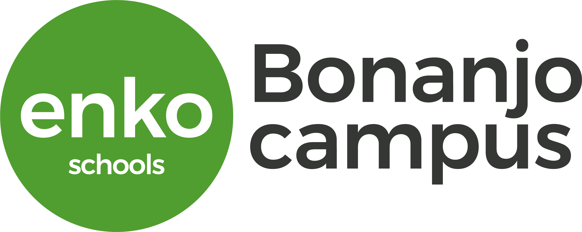

**School Uniform**

The uniform forms part of the school culture at Enko Bonanjo Campus. It is a requirement that students adhere to proper uniform standards.

The table below indicates the requirements.

|  |  |
| --- | --- |
| Girls | Boys |
| White short or long sleeve blouse with school logo | White short or long sleeve shirt with school logo |
| Grey Skirt or Pant | Grey pant |
| Grey Jacket with school logo (Note that the IB Diploma has a darker jacket) | Grey jacket with school logo |
| White Socks | Black socks |
| Black shoes | Black shoes |
| Scarf: Color Red for Forms 1-3; IGCSE and FY; Color Black for IB Diploma | Tie: Red tie for Forms 1-3; IGCSE and FY; Color black for IB Diploma |
| Grey sports suit with school logo- Forms 103 | Grey sports suit with school logo- Forms 1-3 |
| Sports shoes- Forms 1-3 | Sport shoes- Form 1-3 |

Please note: The IB Diploma students are distinguished by wearing a deeper colored grey jacket and pants/skirt and a black tie or scarf.

Student’s name and class should be written discretely on the uniforms

New students who pay registration fees receive 3 logos.

Additional pieces are available for purchase.

Jackets are required for Monday and special occasions.

For the 2020-2021 academic year, we have secured a provider for the uniforms. Parents have the option of purchasing the cloth and sewing the uniform on their own OR purchasing the pieces ready-made.

The pieces of uniform may be purchased at the following cost:

|  |  |
| --- | --- |
| Short-sleeved white blouse/shirt | 7, 500 |
| Long-sleeved white blouse/shirt | 7, 500 |
| Grey pant | 7, 500 |
| Jacket | 10, 000 |
| Skirt | 7, 500 |
| Scarf/Tie | 2, 000 |
| Sports uniform | 6, 500 |
| Logos | 500 |